Hospice modifiers GV and GW

When hospice coverage is elected, the beneficiary waives all rights to Medicare Part B payments for services that are related to the treatment and management of their terminal illness during the period the hospice benefit election is in force. Hospice-related services performed by the "attending physician" who is employed/contracted by hospice, should be submitted to the hospice contractor.

However, professional services of an “attending physician” who is not an employee of the designated hospice or does not receive compensation from the hospice for those services, are submitted to Medicare Part B.

* Professional services of an “attending physician” are submitted with the GV modifier if all conditions are met (description below).
* Any services provided to a patient enrolled in hospice that are not related to the treatment and management of the patient’s terminal illness, are submitted with the GW modifier (description below).

For purposes of administering the hospice benefit provisions, an “attending physician” means an individual who:

* Is a doctor of medicine or osteopathy, or
* A nurse practitioner (for professional services related to the terminal illness and related conditions, or
* A physician assistant; and
* Is identified by the individual, at the time he/she elects hospice coverage, as having the most significant role in the determination and delivery of their medical care.

The following modifiers must be used when billing for services of a patient enrolled in hospice. The appropriate modifier usage will depend on who is providing the service, what services are being provided and if the services are for/related to the reason the patient is enrolled in hospice.

GV Modifier

Attending physician not employed or paid under arrangement by the patient’s hospice provider

This modifier should be used by the attending physician when the services are related to the patient’s terminal condition or not paid under arrangement by the patient’s hospice provider. Also, this modifier must be submitted when a service meets the following conditions, regardless of the type of provider:

* The service was rendered to a patient enrolled in a hospice.
* The service was provided by a physician or non-physician practitioner identified as the patient’s attending physician at the time of that patient’s enrollment in the hospice program.

Some things to keep in mind for patients enrolled in hospice:

* The attending physician may bill Medicare for care plan oversight and other services provided in the treatment of the hospice patient.
* Medicare considers providers who volunteer at the hospice as employees and therefore should not bill Medicare Part B for attending physician services separately.
* If the attending physician has a payment arrangement with the hospice, then the hospice includes the attending physician services in their services billed to Medicare Part A.

Note: Any services submitted without the GV modifier under the conditions outlined above will be denied.

Example: A beneficiary enrolled in Hospice goes to their attending physician's office for closed treatment of a metatarsal fracture, CPT code 28470. If the service is related to the patient's terminal condition and the attending physician is not employed or paid under arrangement by the patient's hospice provider, the attending physician should bill 28470 with modifier GV (28470GV).

Do not submit the GV modifier in the following conditions:

* The service was provided by a physician employed by the hospice.
* The service was provided by a physician not employed by the hospice and the physician was not identified by the beneficiary as his attending physician.

GW Modifier

Service not related to the hospice patient's terminal condition

This modifier should be used when a service is rendered to a patient enrolled in a hospice and the service is unrelated to the patient’s terminal condition. All providers must submit this modifier when:

* The service(s) provided are unrelated to the patient’s terminal condition.
* Claims are submitted for treatment of a non-terminal condition to the Part A MAC with condition code 07.

Note: Any services submitted without the GW modifier under the conditions outlined above will be denied.

Example 1: A beneficiary enrolled in Hospice goes to a physician's office for closed treatment of a metatarsal fracture, CPT code 28470. If the procedure is unrelated to the terminal prognosis, the physician should bill it with modifier GW (28470GW).

Example 2: A beneficiary enrolled in Hospice goes to hospital for closed treatment of a metatarsal fracture, CPT code 28470. If the procedure is unrelated to the terminal prognosis, the hospital reports condition code 07 along with 28470GW.

The following charts should be used to determine when the services of a hospice patient should be covered and when to report the appropriate modifiers.

The Billing Physician Is the Attending Physician

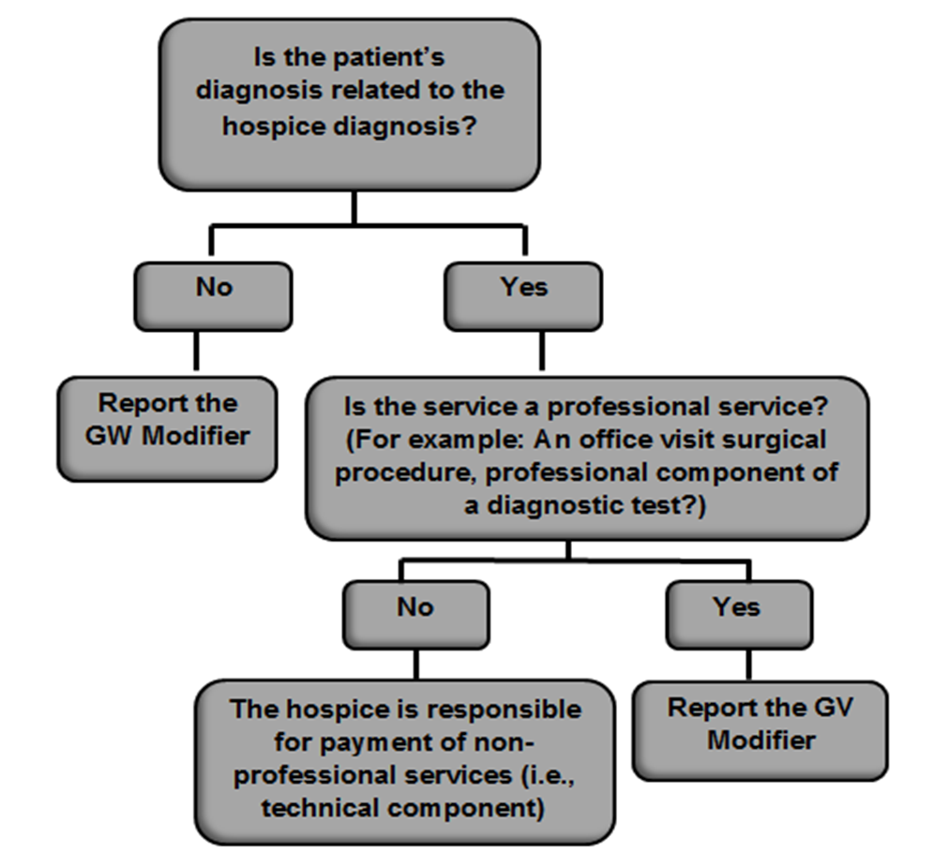

All Other Providers

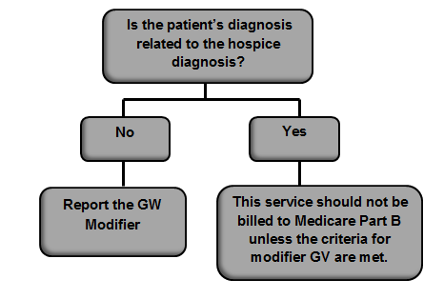

References

* [CMS](https://www.cms.gov/Regulations-and-Guidance/Guidance/Manuals/downloads/clm104c11.pdf) IOM Pub. 100-04, Claims Processing Manual, Chapter 11, section 40
* [Hospice modifiers](ddocname:00144502)
* [Provider specialty: Hospice](ddocname:00003604)