Instructions for completing the Third Party Novitasphere Portal Enrollment form (8291P)
Who should complete this form?
Billing services, and clearinghouses should complete the Third Party Novitasphere Portal Enrollment form to enroll for access to Novitasphere Portal. We are not currently enrolling Veteran’s Affairs providers.
It is important that you use the most recent version of any EDI form when enrolling for EDI services or updating your existing EDI status. Please always complete the forms directly from our website to ensure you are using the most up-to-date documents.
Novitasphere Enrollment Steps
EDI Novitasphere Third Party Portal Enrollment (8291P)
Completing the Novitasphere Third Party Portal Enrollment form (8291P)
Please carefully review the following block-by-block instructions for successfully completing the Third Party Novitasphere Portal Enrollment form. The screen images are for instructional purposes only and cannot be completed and submitted for enrollment.
This is an interactive form that should be completed online and must be printed and signed before submitting.
This form must be completed and approved before requesting a role for this organization in IDM.
General and third-party information
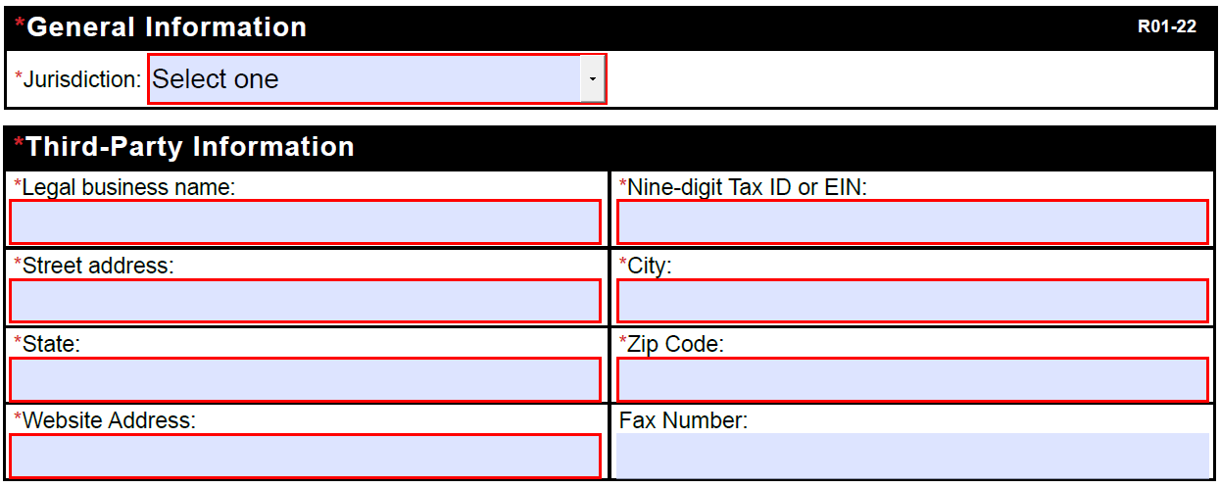
- Select the appropriate Jurisdiction from the dropdown. If you are doing business in both JL and JH states, either may be selected.
- JL states: Delaware, District of Columbia, Maryland, New Jersey, Pennsylvania, J12901
- JH states: Arkansas, Colorado, Louisiana, Mississippi, New Mexico, Oklahoma, Texas, Indian Health Services (IHS), J04911
- Complete the legal business name with the billing service/clearinghouse company name.
- Type the Tax ID.
- Type the complete mailing address for the billing service/clearinghouse enrolling for Novitasphere, including the city, State and Zip Code.
- Type the company’s website address.
- The fax number is optional.
Third-party contact information
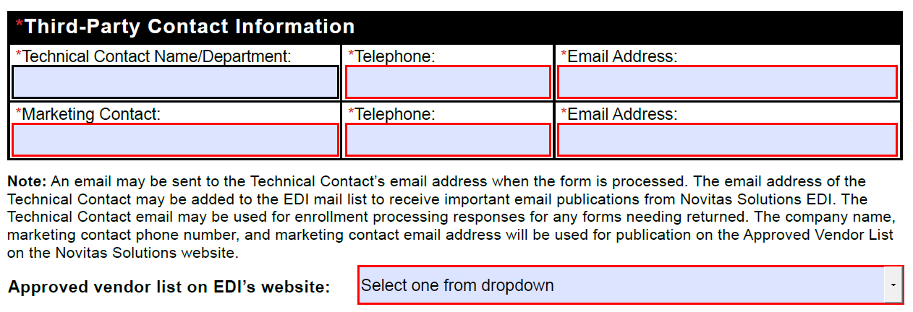
- Complete the technical contact person’s name or department name, telephone number and email address. This information will be added to our electronic mailing lists for important EDI related information and an email will be sent to this address when the form has been processed.
- Complete the marketing contact person’s name, telephone number and email address. This information will be added to the approved vendor list on our website.
- If you do not want to be added to our approved vendor list, select the option to NOT be included from the dropdown list next to “approved vendor list on EDI’s website:”
Novitasphere Portal
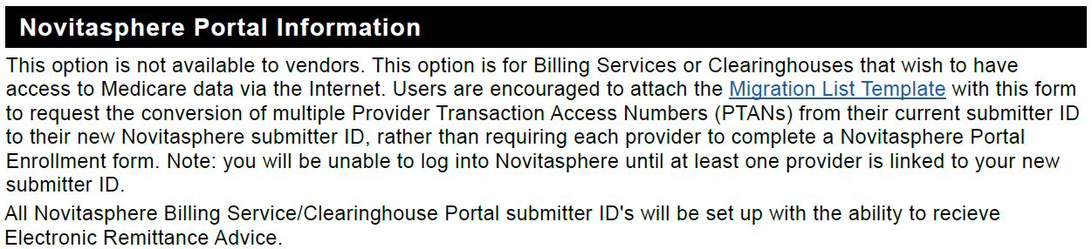
The migration list template is available to send with your form to request the conversion of multiple Provider Transaction Access Numbers (PTANs) from a current submitter ID to a new Novitasphere submitter ID. This would eliminate the need to have each provider complete a Novitasphere Portal Enrollment form. You will not be able to log into Novitasphere until at least one provider is linked to your new submitter ID.
Type of request
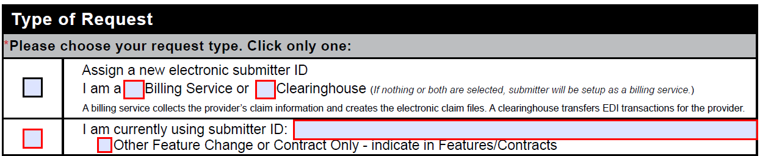
- For initial Novitasphere enrollment, select the box to assign a new Novitasphere submitter ID and select the appropriate box for if you are a billing service or a clearinghouse. If nothing is selected, the submitter ID will be setup as a billing service.
- For existing Novitasphere billing service/clearinghouses making a change, select the second box and type the current Novitasphere submitter ID.
Contracts
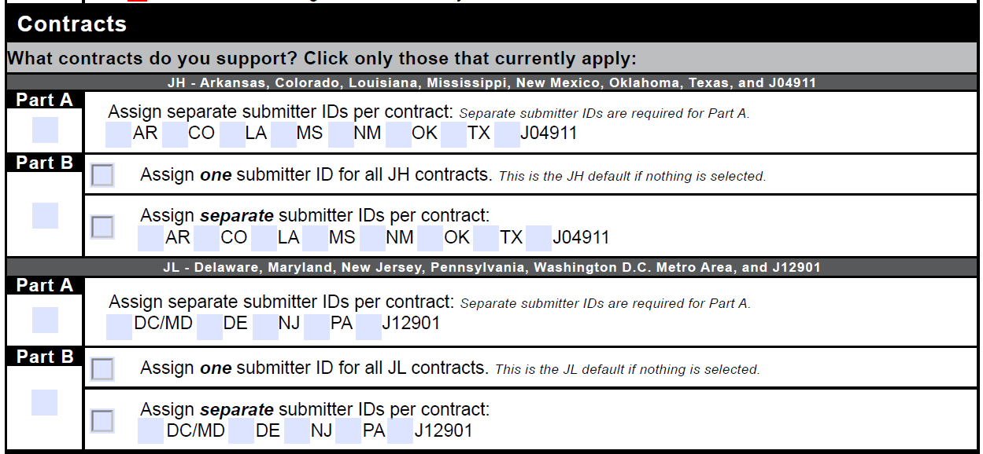
- Select the appropriate contract boxes for which you currently handle Medicare billing. Select only those that currently apply.
- For Part B contracts, select if you want to have one submitter ID for all Part B contracts or separate submitter IDs per contract. Select the appropriate contracts when electing to receive separate IDs.
Features
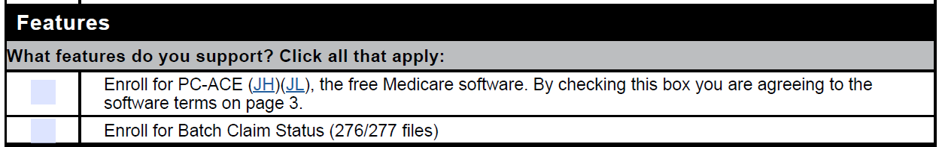
- Select the first box to request or maintain enrollment for the free PC-ACE Medicare billing software.
  - Note: Read the technical requirements and software terms (on page 3 of the enrollment form) carefully before requesting to enroll for PC-ACE.
- Select the second box to request batch claim status files.
  - Note: Novitasphere offers a claim status feature that allows all customers to check claim status on a claim-by-claim basis. This feature is different than these 276/277 files.
  - Note: Verify that your software vendor supports the 276/277 files before requesting to enroll for batch claim status.
Approver designation
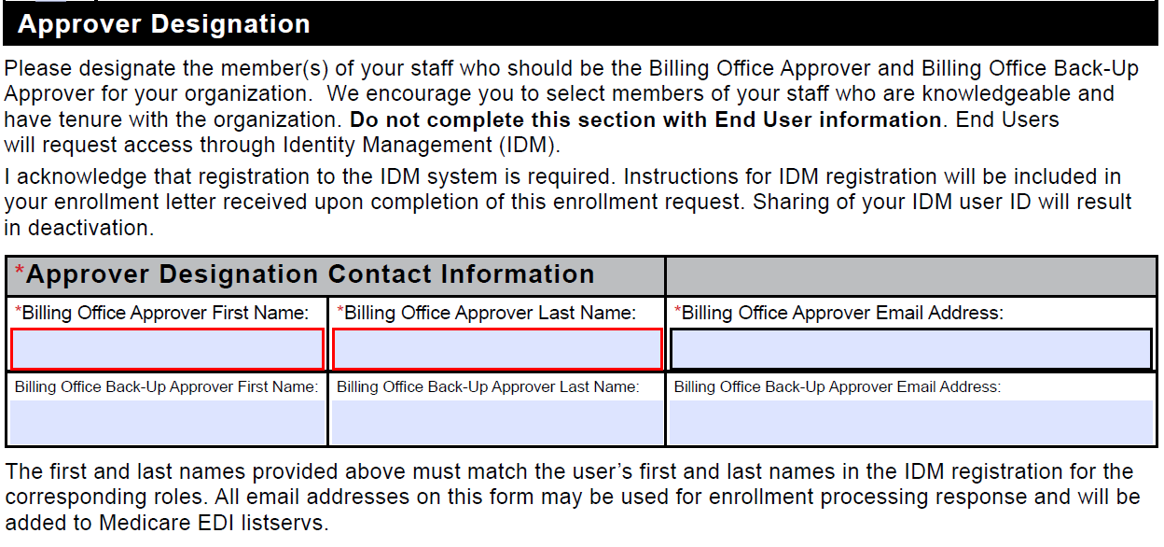
- Complete this section to designate the member(s) of your staff who will be the persons responsible for approving End User access for your organization.
- The billing office approver and billing office back-up approver will be responsible for reviewing and approving your organization’s end user requests for access in Novitasphere.
- Important: When designating member(s) of your staff for these roles, we encourage you to select individuals who will be using Novitasphere on a regular basis and have tenure with the organization.
- Type the first name, last name, and email address for your billing office approver.
- Type the first name, last name, and email address for your billing office back-up approver.
- The back-up approver role shares the same responsibilities as the approver.
- It is strongly encouraged to assign someone to this role, but it is not required.
Required signatures
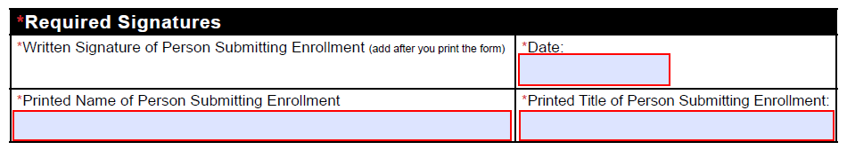
- Type the printed name and professional title of the person submitting the enrollment form.
- This should be an authorized official with the company.
- Type or select the date.
- The date must include the month, day, and year.
- Print the form.
- Sign the form by hand with ink.
- Stamped or typed signatures will not be accepted.
Next steps
- Fax the completed form to 1-877-439-5479. If faxing is not an option, the form can be mailed to the address at the bottom of the form.
- Allow 5-10 business days for processing. Once your form has been processed, an email will be sent to the technical and marketing contact email addresses provided on the form. This email will include details for the next step.
- If there is any missing or incorrect information on your form, the error details will be provided in the response email.

